­­­STRUCTURAL AND MICROSTRUCTURAL ANALYSIS OF THE U-GD-O SYSTEM USING X-RAY DIFFRACTION DATA

|  |
| --- |
| **Gaspar Darin1, Kengo Imakuma2, Luis G. Martinez, Xabier M. Turrrilas, Rodrigo U. Ichikawa, André S. B. Silva Michelangelo Durazzo, Humberto G. Riella4 and Elita Urano5**  1 Instituto de Pesquisas Energéticas e Nucleares (IPEN / CNEN - SP)  Centro de Combustíveis Nuclear  Av. Professor Lineu Prestes 2242  05508-000 São Paulo, SP  [gaspar.filho@ipen.br](mailto:gaspar.filho@ipen.br)  2Eletrobrás Termonuclear S.A. - ELETRONUCLEAR  Departamento GLN – G  Rua da Candelária, 65 – 9º andar  20091-906 Rio de Janeiro, RJ  [rarcuri@eletronuclear.gov.br](mailto:rarcuri@eletronuclear.gov.br) |

# ABSTRACT

Gadolinium is one of the best neutron absorber materials and its use can be considered as a burnable poison for Light Water Reactors (LWR) and as a sacrificial material in Sodium Fast Reactor (SFR). Most of the experiments in the literature focus on nuclear fuel with up to 12 wt% Gd2O3. Recently, the phase diagram and melting point has been investigated for high contents of Gd2O3 in the U-Gd-O system.  
In this work, we present the analysis of the U-Gd-O system for high contents of Gd2O3 using X-ray diffraction data. Rietveld analysis was applied to obtain cell parameters, atomic positions and atomic displacement factors and compared with literature ones. Also, the quantification of phases was performed for the different contents of Gd2O3 in the system. Finally, mean crystallite sizes were determined and correlated with the weight fraction of the phases.

# INTRODUCTION

The U–Gd–O system is of interest for nuclear industry because gadolinium is one of the best neutron absorber material. It is most used burnable absorbers in Light Water Reactors (LWR) as well as sacrificial material in Sodium Fast Reactor (SFR). When U-Gd-O system is used as burnable poison, gadolinium-doped UO2 pellets are obtained by sintering gadolinia and urania mixed powders (<40 wt% of Gd2O3). However, a complete homogenization of UO2 and Gd2O3 precursor powders is difficult to achieve. That is the reason why an accurate knowledge of the thermodynamic phase diagram is needed [1]. Besides that, in order to increase the safety of SFR reactors, gadolinium is used as sacrificial material. In this way, several accidents due to overheating could be avoided, or in the worst case, their consequences reduced [2].

UO3–UO2–Gd2O3 system has been studied almost exclusively for low Gd content samples (<40 wt% of Gd2O3) [2,3]. For low gadolinium content a cubic FCC phase is obtained [4–8] after sintering under different H2 pressures. In this solid solution, Gd3+ cations arrange themselves at U4+ sites in UO2 fluorine structure. Beals has measured the lattice parameter after air sintering showing that the lattice parameter get smaller due to oxidation [2]. For Gd content higher than 0.50 gadolinium-to-metal atomic ratio (Gd/M), a d-Gd6UO12 phase was found by Aitken et al. [3]. Finally, it is reported that pure Gadolinia can exist under three different crystalline forms: A (hexagonal), B (monoclinic) and C (cubic BCC) [10]. The cubic form is the more thermodynamically stable at ambient temperature and atmospheric pressure. The monoclinic phase can also be found in co-existence with the cubic phase at room temperature. In order to investigate the crystalline phase and crystallite size formed in these conditions at thermodynamic equilibrium, some samples with composition (U1-y, Gdy)O2±x for Gd/M values ranging from 0.50 to 0.85 were fabricated. [1]

Final PDF file size should be no more than 4 MB. Recommended paper length is 5-15 pages, suggested 8-12.

# MATERIALS AND METHODS

## 2.1. Material synthesis

In this work the U1-xGdxO2 solid solutions samples have been prepared by coprecipitation method. The gadolinium oxide, purity 99.9%, was supplied from Ventron Alfa Produkte, FRG. The UO2 powder used in the dry blended powders process was obtained from uranium hexafluoride via the AUC (ammonium uranyl carbonate) conversion [12].

In the coprecipitation method, the aqueous solutions of uranyl nitrate, UO2(NO3)2, and gadolinium nitrate, Gd(NO3)3, were prepared by dissolving U3O8 and Gd2O3 powders with 7N nitric acid. The precipitation of AUC and ADU was carried out in a batchmanner. The uranyl and gadolinium nitrate solutions were thoroughly blended together in varying proportions between 50 and 85 wt% Gd2O3, main characteristics are resumed in table 1. An uranyl nitrate solution containing 400 g U/l mixed with Gd-nitrate solution was slowly added to freshly prepared 101 ammonium carbonate solutions to produce AUGdC precipitates. Stirring was applied with a glass rod during the addition of the solution. The precipitation temperature was 60 °C and the final pH value close to 8.3. The AUGdC slurry was filtered in vacuum and washed with ethanol to improve the drying rate.

A variety of ADU precipitates with different Gd2O3 quantities was prepared by adding NH4OH to UO2(NO3)2-Gd(NO3)3 solution at 60°C and pH 9. Vacuum filtration was performed by using a funnel with perforated plate. After filtration, the wet precipitates were dried in an oven at 80°C during 24 h. [3]

The mixtures were granulated and compacted into pellets at 440 MPa. Pellets were 10 mm in diameter and 12 mm in height. Finally, all green pellets were sintered simultaneously

in a tungsten crucible in flowing Ar H2 5% (the oxygen potential is estimated to -450 kJ mol-1). Heating rate was 1 °C/min. Samples were heated up to 1660 °C during 3 h and the cooling down rate was 1 °C/min. [2]

## 2.2. Crystallite size analysis

Scherrer (1918)[12] found that the breath of a diffraction line is related to the finit size of the diffraction crystal, and make the famous equation:

|  |  |  |
| --- | --- | --- |
|  |  |  |

Where the constant K depend of crystallite shape, λ is wavelength, is the full width at half height (FWHM) and θ angular position.

After this propose, Langford [13]related the breath with finit size of diffraction and microstrain, for separate this two values, used the Voigt function,

|  |  |  |
| --- | --- | --- |
|  |  |  |

being the integrated width of the Lorentzian profile, D the crystallite size.

|  |  |  |
| --- | --- | --- |
|  |  |  |

being the integrated width of the Gaussian profile, ε is a microstrain.

Warren and Averbach [14] related the fourier coefficients with both, but is required two or more diffraction parallels plane:

|  |  |  |
| --- | --- | --- |
|  |  |  |

Where is the mean square strain and L is the Fourier length, defined as:

|  |  |  |
| --- | --- | --- |
|  |  |  |

And Ɵ1 and Ɵ2 is the minimum and maximum diffraction profile

## 2.3. Quantitative XRD by Rietveld Method

## Quantitative phase analysis of bauxites and their dissolution products

## *Bee K. Gan a,, Zoe Taylor, Bingan Xu, Arie van Riessen, Robert D. Hart, Xiaodong Wang, Peter Smith*

The Rietveld method (Rietveld, 1967, 1969) is a pattern modelling procedure in which the set of intensities comprising the calculated pattern, determined according to an initial model, is fitted by non-linear least squares to the corresponding measured pattern. Structural parameters (atomic positions, thermal parameters, site occupancies and lattice parameters), pattern background function coefficients, scale factors for phase composition determination, preferred orientation, extinction, profile parameters (peak widths and shape), crystallite size and microstrain (through profile parameters) may be included in Rietveld analysis (Young, 1993). Least squares Rietveld refinement is designed to minimize the residual summed over the n points in the pattern at which the intensity is sampled (Rietveld, 1969).

R = Σwi(yio-yk)2

where yio and yic are the observed and calculated intensity at the ith step, respectively, and wi is the weight assigned to each observation which is normally set to the inverse of the counting error variance (σi 2) at the ith step. Numerous R factors are used in Rietveld refinements to measure the progress of the Rietveld refinement (Young and Wiles, 1982), with the most meaningful being the weighted profile R factor (Rwp) as the numerator in the expression is the quantity being minimised by least squares during refinement.

Rwp = (Σwi(yio-yk)2 / Σwiyio2 )^0,5

Quantitative phase composition results are obtained when a known amount of internal standard is added to the polyphase mixture and the entire pattern is fitted using the Rietveld method. The concentration for a particular crystalline phase, Wk, is given by

Wk = Ws(ZMV)k . Sk / (ZMV)s . Ss

where Ws is the known wt.% of the internal standard in the mixture, S is the Rietveld scale factor, ZM is the unit-cell mass and V is the unit-cell volume. In this study, the amorphous level was not modelled but determined as the difference between the sum of the analysed weight fractions for all crystalline phases and 100% and may also refer to poorly ordered phase(s) and/or undetected phase(s) after Rietveld refinement.

XRD measurements was performed on powder samples of each batch using a D8 Advance Bruker diffractometer with a copper X-ray source Kristalloflex K760A2 (ka1 = 1.54056 Å et ka2 = 1.5444 Å). A nickel filter was used to filter copper Kb wavelength. Angular step was of 0.02°. Diffractograms were obtained by Bragg-Brentano geometry for Powder Diffraction Method. Crystalline phases in the XRD patterns were identified using Bruker® Diffracplus EVA v16 software to search the ICDD® Powder Diffraction File (PDF4+ 2010 edition). The crystal structures of the phases were extracted from the FIZ Karlsruhe Inorganic Crystal Structure Database (ICSD 2009/2) in the form of crystallographic information files (.cif). Bruker® (2008) TOPAS v4.2 was used to perform Rietveld quantitative analyses.

**Table 1: Gadolinia content in fabricated batches at 1650 °C under Ar H2%5.**

|  |  |  |  |  |
| --- | --- | --- | --- | --- |
| Batch | Wt% Gd2O3 | Gd/M  (atomic ratio) | Gd/U  (atomic ratio) | O/M  (atomic ratio |
| #1 | 50,18% | 0,63 | 1,90 | 1,78 |
| #2 | 56,58% | 0,66 | 1,94 | 1,75 |
| #3 | 61, 04% | 0,71 | 1,98 | 1,72 |
| #4 | 66, 83% | 0,75 | 3,02 | 1,69 |
| #5 | 74,11% | 0,81 | 3,08 | 1,64 |
| #6 | 85,81% | 0,90 | 3,17 | 1,57 |
|  | | | | |

# 3. RESULTS

## 3.1. Diffraction patterns of the powdered samples

## 3.1.1. Batch #1 (50 wt% Gd2O3)

X-ray diffraction pattern from Bruker diffractometer showed almost only one single pure phase, Fig. 1. A FCC cubic crystalline structure, with lattice parameter of a = 5.3866 ± 0.0001 Å, and a BCC cubic crystalline structure, with lattice parameter of a = 10.847 ± 0.004 Å, was proposed from obtained data. In spite of the very high gadolinia content, the BCC phase was detected in a very low proportion. Quantum Phase Analysis Method gave us 94.58 % for FCC (fluorite) and 5.42 % for BCC cubic phase. The crystallite size found for BCC phase was 18 ± 14 Å (weight 18 ± 2 %) and for FCC phase 159 ± 11 Å (weight 82 ± 2 %). [1]

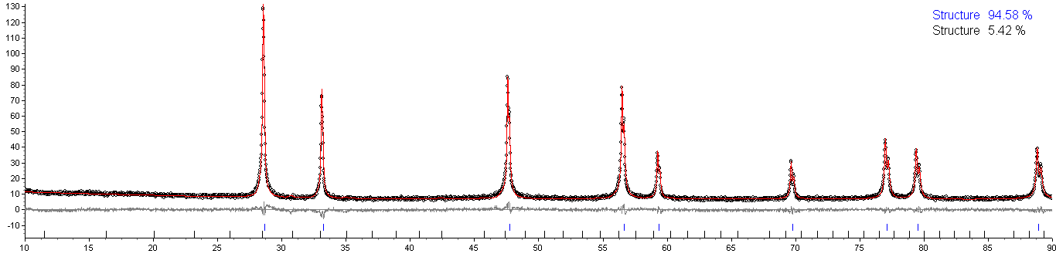

**Figure 1: XRD for batch #1. FCC and BCC cubic phase were found with cell parameter a = 5.3866 ± 0.0001 Å and a = 10.847 ± 0.004 Å, respectively.**

## 3.1.2. Batch #2 (53 wt% Gd2O3)

X-ray diffraction pattern showed almost only one single pure phase, Fig. 2. A FCC cubic crystalline structure, with lattice parameter of a = 5.3949 ± 0.0001 Å, and a BCC cubic crystalline structure, with lattice parameter of a = 10.857 ± 0.008 Å, was proposed from obtained data. In spite of the very high gadolinia content, the BCC phase was detected in a very low proportion. Quantum Phase Analysis Method gave us 96.59 % for FCC (fluorite) and 3.41 % for BCC cubic phase. The crystallite size found for BCC phase was 30 ± 18 Å (weight 30 ± 2 %) and for FCC phase 151 ± 12 Å (weight 70 ± 2 %). [1]

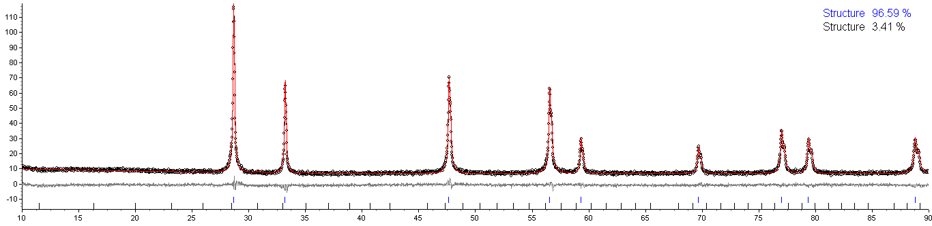

**Figure 2: XRD for batch #2. FCC and BCC cubic phase were found with cell parameter a = 5.3949 ± 0.0001 Å and a = 10.857 ± 0.008 Å, respectively.**

## 3.1.3. Batch #3 (56 wt% Gd2O3)

X-ray diffraction pattern showed almost only one single pure phase, Fig. 3. A FCC cubic crystalline structure, with lattice parameter of a = 5.3881 ± 0.0001 Å, and a BCC cubic crystalline structure, with lattice parameter of a = 10.849 ± 0.005 Å, was proposed from obtained data. In spite of the very high gadolinia content, the BCC phase was detected in a very low proportion. Quantum Phase Analysis Method gave us 94.98 % for FCC (fluorite) and 5.02 % for BCC cubic phase. The crystallite size found for BCC phase was 30 ± 18 Å (weight 30 ± 2 %) and for FCC phase 151 ± 12 Å (weight 70 ± 2 %). [1]

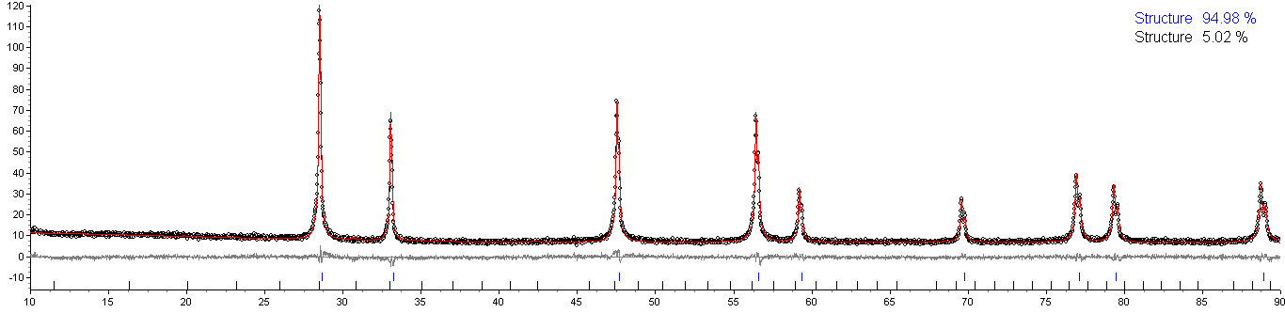

**Figure 3: XRD for batch #3. FCC and BCC cubic phase were found with cell parameter a = 5.3881 ± 0.0001 Å and a = 10.849 ± 0.005 Å, respectively.**

## 3.1.4. Batch #4 (61 wt% Gd2O3)

X-ray diffraction pattern showed almost only one single pure phase, Fig. 4. A FCC cubic crystalline structure, with lattice parameter of a = 5.4066 ± 0.0002 Å, and a BCC cubic crystalline structure, with lattice parameter of a = 10.848 ± 0.004 Å, was proposed from obtained data. In spite of the very high gadolinia content, the BCC phase was detected in a very low proportion. Quantum Phase Analysis Method gave us 93.93 % for FCC (fluorite) and 6.07 % for BCC cubic phase. The crystallite size found for BCC phase was 94 ± 7 Å (weight 95 ± 2 %) and for FCC phase 46 ± 7 Å (weight 5 ± 2 %). [1]

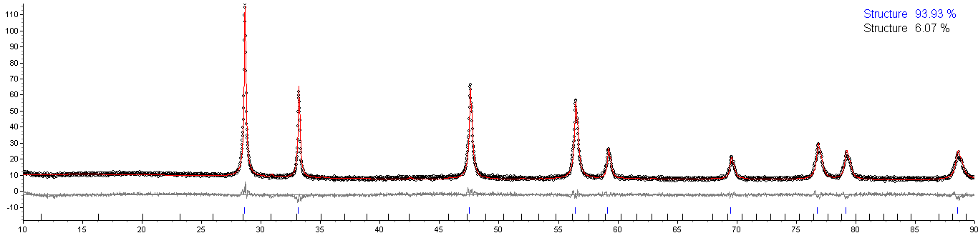

**Figure 4: XRD for batch #4. FCC and BCC cubic phase were found with cell parameter a = 5.4066 ± 0.0002 Å and a = 10.848 ± 0.004 Å, respectively.**

## 3.1.5. Batch #5 (66 wt% Gd2O3)

X-ray diffraction pattern showed almost only one single pure phase, Fig. 5. A FCC cubic crystalline structure, with lattice parameter of a = 5.4256 ± 0.0002 Å, and a BCC cubic crystalline structure, with lattice parameter of a = 10.8543 ± 0.0009 Å, was proposed from obtained data. This time, the sample compound can’t be approximate to a single FCC cubic phase. Because QPA results in 71.87 % for FCC (fluorite) and 28.13 % for BCC cubic phase proportion. The crystallite size found for BCC phase was 71 ± 4 Å (weight 95 ± 2 %) and for FCC phase 35 ± 8 Å (weight 5 ± 2 %). [1]

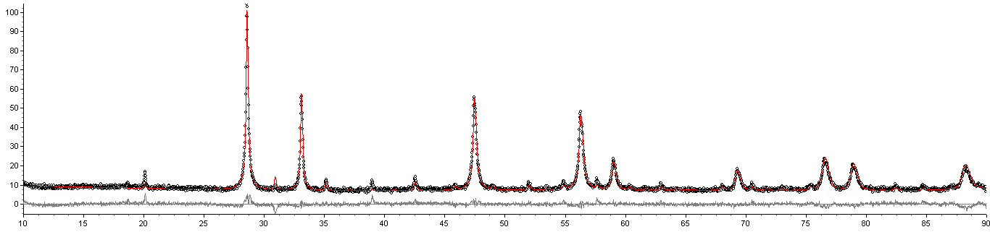

**Figure 5: XRD for batch #5. FCC and BCC cubic phase were found with cell parameter a = 5.4256 ± 0.0002 Å and a = 10.8543 ± 0.0009 Å, respectively.**

## 3.1.6. Batch #6 (74 wt% Gd2O3)

X-ray diffraction pattern showed almost only one single pure phase, Fig. 6. A FCC cubic crystalline structure, with lattice parameter of a = 5.4311 ± 0.0001 Å, and a BCC cubic crystalline structure, with lattice parameter of a = 10.8619 ± 0.0004 Å, was proposed from obtained data. From here, the difference between BCC phase proportion and gadolinia content starts to decrease significantly. Quantum Phase Analysis Method gave us 44.19 % for FCC (fluorite) and 55.81 % for BCC cubic phase. The crystallite size found for BCC phase was 192 ± 20 Å (weight 93 ± 1 %) and for FCC phase 21 ± 3 Å (weight 7 ± 1 %). [1]

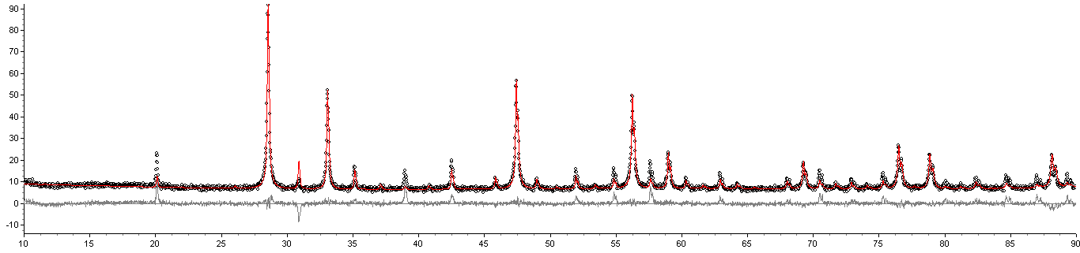

**Figure 6: XRD for batch #6. FCC and BCC cubic phase were found with cell parameter a = 5.4311 ± 0.0001 Å and a = 10.8619 ± 0.0004 Å, respectively.**

## 3.1.7. Batch #7 (85 wt% Gd2O3)

X-ray diffraction pattern showed almost only one single pure phase, Fig. 7. A FCC cubic crystalline structure, with lattice parameter of a = 5.4226 ± 0.0002 Å, and a BCC cubic crystalline structure, with lattice parameter of a = 10.8448 ± 0.0004 Å, was proposed from obtained data. From here, the difference between BCC phase proportion and gadolinia content starts to decrease significantly. Quantum Phase Analysis Method gave us 30.33 % for FCC (fluorite) and 69.67 % for BCC cubic phase. The crystallite size found for BCC phase was 163 ± 13 Å (weight 96 ± 1 %) and for FCC phase 16 ± 8 Å (weight 4 ± 1 %). [1]

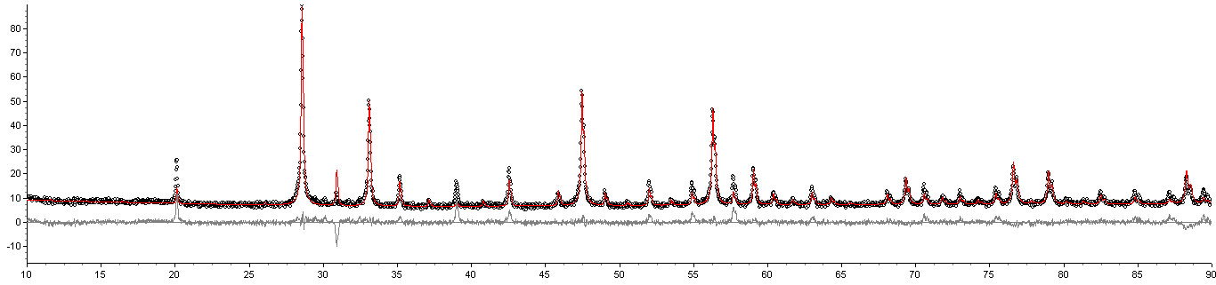

**Figure 7: XRD for batch #7. FCC and BCC cubic phase were found with cell parameter a = 5.4226 ± 0.0002 Å and a = 10.8448 ± 0.0004 Å, respectively.**

## 3.2. Quantitative Phase Analysis

EXPLORAR O PONTO FOR A DA CURVA, ATRAVÉS DOS TRABALHOS DO FRANCÊS E MICHELANGELO. TENTAR EXPLICAR ESTE COMPORTAMENTO.



**Figure 8: XXXXXXXXXXXXXXXXXX**



**Figure 9: YYYYYYYYYYYYYYYYYYYYYYYYYYY**

## 3.3. Lattice parameter vs Gd2O3 wt%

XRD was performed on polished sample disks of each batch using a D8 Advance Bruker diffractometer with a copper X-ray source Kristalloflex K760A2 (ka1 = 1.54056 Å et ka2 =



**Figure 9: Water-filled borehole using conventional discrete ordinates formulation for the transport equation.**

## 3.4. Crystallite size

XRD was performed on polished sample disks of each batch using a D8 Advance Bruker diffractometer with a copper X-ray source Kristalloflex K760A2 (ka1 = 1.54056 Å et ka2 =



**Figure 10: Water-filled borehole using conventional discrete ordinates formulation for the transport equation.**

# 4. DISCUSSION

Present your summary, list your concluding remarks and suggestions for future work here.

# 5. CONCLUSIONS

Present your summary, list your concluding remarks and suggestions for future work here.

# ACKNOWLEDGMENTS

This template was adapted from the template for the American Nuclear Society Topical Meeting in Mathematics & Computations, Gatlinburg, TN, 2003 posted on the Internet. Acknowledge the help of colleagues, and sources of funding, if you wish.

# REFERENCES

1. D. Pieck, L. Desgranges, P. Matheron, H. Palancher, “Evidence of a new crystalline phase in U-Gd-O phase diagram,” *Journal of Nuclear Materials*, **Volume 461**, pp.186-192 (2015).
2. C. Journeau, P. Fourquart, R. Domenger, P. Allegri, “Hypoeutectic melting in the UO2-x-Gd2O3 system” *Journal of Nuclear Materials*, **Volume 488**, pp.287-294 (2017).
3. H. G. Riella, M. Durazzo, M. Hirata, R. A. Nogueira, “UO2-Gd2O3 solid solution formation from wet and dry processes” *Journal of Nuclear Materials*, **Volume 178**, pp.204-2011 (1991).
4. “Spallation Neutron Source: The next-generation neutron-scattering facility for the United States,” <http://www.sns.gov/documentation/sns_brochure.pdf> (2002).

12. E. J. Mittemeijer and U. Welzel, “The ‘state of the art’ of the diffraction analysis of crystallite size and lattice strain,” Zeitschrift fur Krist., vol. 223, no. 9, pp. 552–560, 2008.

13 De Keijser, Th H., et al. "Use of the Voigt function in a single-line method for the analysis of X-ray diffraction line broadening." Journal of Applied Crystallography 15.3 (1982): 308-314.

14.B. E. Warren, “X-ray diffraction methods,” *J. Appl. Phys.*, vol. 12, no. 5, pp. 375–383, 1941.

Equations should be centered and sequentially numbered to the flush right of the formula. That is, we write for example the steady-state equation of continuity

|  |  |
| --- | --- |
| . | (1) |

The continuation of a paragraph after an equation is not indented. All paragraphs, as well as section or subsection headings, are separated by just one single empty line.

## 2.1.1. Sub-subsection level and lower: only first character uppercase

Figures and tables should appear as closely as possible to where they are first cited, e.g. Fig. 1, in the text. Figures are numbered in Arabic numerals, with the caption centered below the figure, in **boldface**. Double-space before the figure, and after the figure caption.

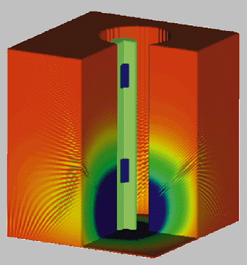

**Figure 1: Water-filled borehole using conventional discrete ordinates formulation for the transport equation.**